The Colors of Emotion
Chloe Webb
Department of Psychology, Juniata College
PY361 Research Methods & Stats II
Dr. Philip Dunwoody
May 5, 2023

Abstract
This study is aimed at testing the relationship between Warm and Cold colors and the Positive and Negative emotions associated with them. This is done by analyzing three main hypotheses; (Hypothesis 1) Warm colors elicit more Positive emotions than Negative emotions. (Hypothesis 2) Cold colors elicit more Negative emotions than Positive emotions. (Hypothesis 3) There is a statistically significant relationship between the two color temperatures and the emotions they elicit. A total of N = 35 participants were represented within this study. The data was analyzed through two Frequency tables and one Chi-squared test. The results supported Hypothesis one, but were non-supporting of Hypothesis two and three. As Cold color still was more frequently Positive, and there were no significant associations present within the Chi-square test. The contingency coefficient, Phi-coefficient, and Cramer’s V were all approximately 0.108, also suggesting little to no relationship. Further research is needed to more thoroughly test the complicated relationship between color and emotions.
Keywords: Warm colors, Cold colors, color temperature, Positive emotions, Negative emotions

Introduction
Have you ever wondered why the most common color for nursing scrubs is blue? How about why McDonald’s uses the colors red and yellow? Surprisingly, it is not only for eye-catching branding. McDonald’s marketers use red and yellow in order to elicit our “hunger” response. We have also seen that the color blue is often associated with “trust”. Thus, having nurses wear blue scrubs may make you more inclined to trust them. Color Psychology is the study of how color affects human behaviors and emotions. Countless research studies have shown us that colors can have a large array of effects on people. Some emotions and behaviors may be able to be manipulated by color. For example, what if a majority of people became irate after spending over an hour in a red room? What if spending an hour in a blue room would have an opposing effect? Can marketers use Color Psychology to help their products elicit specific responses?
The effects of a color named Baker-Miller Pink, for example, has been broadly studied over the years. This color was named after two U.S. Naval Officers who tested the effect of it on those detained in a Naval correctional facility. A later study conducted by Schauss (1981) showed that Baker-Miller Pink reduced blood pressure, aggression, and violent behavior. The color’s effects were found to be strongest during the fifteen minutes after first exposure. After that, the previously mentioned response would begin to decrease in effectiveness. However, some studies have shown overall opposing results. When tested on certain prisons, the prisoners began to act out more than they did without the color present. Some researchers believe this to be prisoners acting in spite of the eccentric pink color, instead of because of it, Gilliam et al. (1988). This included behaviors associated with anger, irritation, and acting out against the guards. These conflicting results demonstrate that the effects were not universally positive. Although the research behind Baker-Miller Pink has not been solidified, many still believe it to affect certain human behaviors and physiology. More research should be done in order to better understand the effects of Baker-Miller Pink, and how it can be properly utilized.
Often, corporations use color research to market products more efficiently to their audience. This can be seen in a lot of different marketing material all over the world. The example mentioned before of McDonalds can easily represent this fact. Factors such as age, culture, and gender, can all affect how a person views color. Marketers and Graphic Designers spend a lot of time studying how to properly use color for more than just aesthetics. In this study, surveying Juniata College students, participants will be asked questions relating to “which they prefer”. This will be done by presenting multiple different products, sports teams, and foods, all of which are differentiated by warm or cold colors. Participants will also be asked to choose how that image made them feel on a positive or negative scale. Colors can affect how humans behave in certain circumstances. This study should show what colors elicit certain behaviors in college students. This research can then be used by marketers and people studying color in order to use it more effectively.
Literature Review
Consumer behavior is something broadly studied by Marketers and those alike in other fields. For example, as mentioned in the introduction, Baker-Miller Pink has been studied for its supposedly calming physiological and psychological effects, Gilliam et al. (1988). Shi et al. (2013) took a deep delve into the implications of the physiological and psychological effects of color specifically. Stillman et al. (2020) studies the sensory experiences related to color by taking a Neuroscience approach. “Color is the first and most important factor in the attractiveness of packaging”, Babolhavaeji et al. (2015). This is also echoed by Mohebbi et al. (2014), when arguing that color plays an important role with the promotion of a product, thus Product Designers should pay extra attention to this aspect. Khattak et al. (2018), mentions how people pass judgment on other people and products within 90 seconds of being exposed to them. These researchers also mention how about 62-90% of these judgments are based on viewed color solely.
Many researchers have studied the effects of color in shopping-related environments. A study by Bellizzi et al. (1992) tested the effects of the colors red and blue. They were selected specifically because of their opposing color properties. This study found that blue environments yielded more positive purchasing than red environments. For example, blue environments yielded more purchased items, fewer customer hesitation, and longer time spent within the store. Huang J. et al. (2020) looks at similar color effects by using a scale of arousal when studying product background colors. When a product color matches the product’s type, customers receive it better. This is also similar to a study by Huang L. et al. (2015) discussing how a package's color influences how a person may perceive its taste and healthiness. Woodside et al. (2008), discusses the feeling that certain brands, products, and colors give off. The researchers mention how these aspects can somewhat tell a story within them. Saad et al. (2000), studies similar effects of color, yet uses Evolutionary Psychology as its framework. Pratt et al. (2020), discusses how people, whether they acknowledge it or not, have a preconception of what certain colors represent to them personally. Some people may view color differently, but there tends to be overarching consistency overall.

Methods
Participants
The participants in this study consist of Juniata College students over the age of 18. 47 people, in total, gave their responses. Sadly, only 35 of those were usable. There were no limitations, such as Program of Emphasis (Major), race, gender, or anything along those lines, in order to participate. No specific demographic information was collected for this study either, as the sample was meant to be broad. However, there was a question referring to whether the participants experience any sort of color blindness. Two participants who answered “Yes”, were removed from the overall data pool. Future studies should take colorblindness and demographic information into consideration when looking for more generalizable results. This survey could also be taken anywhere, PC or mobile, at any time before data collection concluded. Students were confronted with an informed consent form before being allowed to fill out the survey. By accepting, they would have given their informed consent to continue onto the first question. However, they always had the opportunity to exit at any time without consequence. The data collected was solely anonymous, and left no trace back to the original participant. No participants had prior knowledge pertaining to the survey. Data collection began on February 23rd, and ended on March 23rd, an exact month later.
Procedures
This study looks at color and the frequency of emotions elicited from employing warm colors and cold colors in a series of images. The cold colors used will be; Blue, Purple, and Green. The warm colors tested will be; Yellow, Red, and Orange. The exact hue of the colors may vary slightly, but mostly stay consistent. Images included sports teams, food items, and everyday products. Then, participants were asked to choose their preference out of two images. These images were matching per question (i.e. two scoops of ice cream), with the only change relating to different hues, warm and cold. Pictures were chosen by selecting Google images that looked as identical as possible to complete a matching pair.
Measures
Participants were presented with two images of each item. They were then asked to choose which item (1 or 2) they prefer. Warm colored items were labeled “Product 1”, whereas cold colored items were labeled “Product 2”. This order was held consistent throughout the survey. Finding literature scientifically discussing what makes a color warm, versus what makes a color cold, proved to be a challenge. This study used warm and cold colors defined as the feeling “tone” that they give off most consistently. Cold colors give off more soothing and calming tones, whereas warm colors give off more bold and brash tones. Another defining feature of cold and warm colors are their placements on the color wheel. Splitting the color wheel in half reveals two sides with similar tones. The opposing side of the color wheel yields the opposite color temperature.
After being asked which image is preferable, the students will also be asked how that image made them feel. The options will be from a set list of different emotions, measured as positive or negative. The emotions will consist of simple and understandable options; Happy, sad, fearful, angry, trusting, interested. Three of these options will be measured as negative, and three will be measured as positive. Happy, trusting, and interested will be measured as positive. Sad, fearful, and angry will be measured as negative. Thus, warm and cold colors were tested and compared through different item images by personal preference. Then, tested again through positive and negative emotions.

Discussion
This study looks to find the frequencies between emotions and color temperatures. As in most studies, discrepancies could be found that limit the validity and generalizability. These discrepancies can show as limitations within the study. Limitations can be found within any aspect, such as demographic, generalizability, scale, and technology. Some of these will be discussed within this limitation section. Understanding limits allows for better, more informed future studies to take place.
Limitations of This Study
In this study, there was little to no demographic data collected. Although all participants were supposed to be Juniata College students over the age of 18, not much else is known about them. Collecting demographic data, such as data on race, ethnicity, and gender, can allow for more validity within the results. This way, your data will show if a certain population, such as women, were underrepresented within your sample. As there was no demographic collection, it is impossible to tell if the data represented populations evenly. Other demographics relating to college students in particular are POEs/Majors. Since this also was not collected, there is no way to test correlations between certain majors if that exists. Ultimately, limiting the extra tests that could have been performed.
One question in the survey asked the participants if they were color blind. Had the participant answered “Yes”, they would be removed from the data. However, not everyone may know whether they are color blind or not, and color blindness comes in many different forms. Since it was self-reported, participants could have responded opposite to what they actually are, knowingly or not.
In addition to demographic limitations, sample limitations are often large factors within a study's validity. In trying to test an entire college, a sample size of 35 is rather small and non-encompassing of the whole population. Especially when knowing how diverse Juniata, and many other colleges, are. Sample types may also play a role in limiting generalization. For this survey, advertisements were sent over daily college announcement emails. Thus, making it Convenience Sampling. When testing only Juniata College students, these results should not attempt to be generalized towards more or all colleges. Nor should it attempt to be generalized towards non-college attending adolescents, as their results may be different.
Results
To assess whether there is a relationship between color temperatures (Warm and Cold) and emotions elicited from them, this study performed multiple tests. These tests included Frequency tables and a Chi-squared table. This was in order to compare both internally, and externally, whether these categorical variables were interdependent or associated.
Table 1
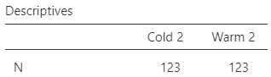
Descriptive Statistics of Cold and Warm Color Responses

The first two tests conducted on the survey data were Frequency tests. These were done to view the relationship internally of Positive and Negative emotions elicited within each color temperature. In the frequency tables, color temperatures are labeled “Warm 2” and “Cold 2”. These are not significant to any differentiated data, instead, just how they were labeled after defining the variables within Jamovi. Viewing the results of each individual Frequency table yielded the results expected. Warm colors elicited higher rates of Positive emotions than Negative emotions. Thus, Hypothesis 1 was supported. However, when analyzing the frequency table for Cold colors, it is seen that there are more Positive emotions than Negative emotions present. Thus, not supporting Hypothesis 2. Although nonsupporting of this hypothesis, it is still interesting to note that Cold color temperatures elicited a higher frequency overall of Negative emotions than Warm colors did. Not only is this represented through the frequency tables, it is also represented more visually through a bar graph below.
Table 2
Frequency tables for Warm and Cold colors and their Positive and Negative elicited
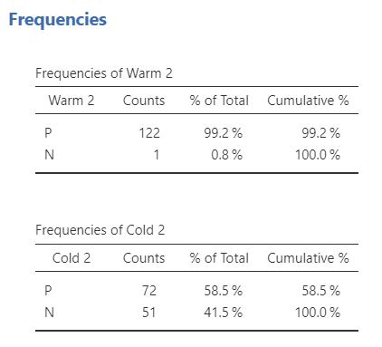

Figure 1
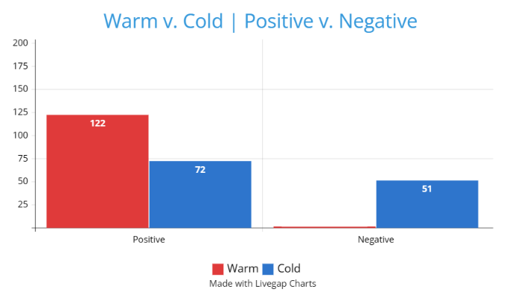
Bar plot representing Warm and Cold colors with Positive and Negative emotion responses

The final analysis conducted was a Chi-squared test. This is meant to test the relationship externally between the two color temperatures and their elicited emotions. The data showed little to no significant association between color temperature and emotion overall within this test. As seen in the Chi-squared table below with X^2 = 1.42, df = 1, and p = 0.233. The contingency coefficient, Phi-coefficient, and Cramer’s V are all measures of association between nominal variables. In this test, they all yield very similar results, being 0.107 or 0.108. This also suggests a weak association between variables. Thus, not supporting Hypothesis 3, the final one.
Table 3
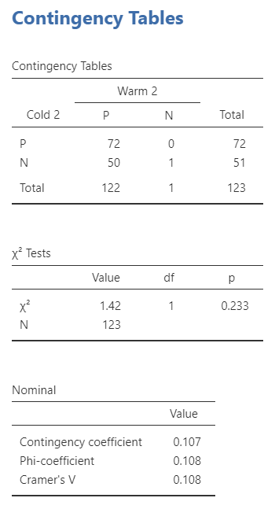
Chi-squared test yielding non-statistically significant results

Conclusion
The frequency tables supported Hypothesis one, Warm colors had a higher frequency of Positive emotions, but the opposite in Hypothesis 2 was not supported. The results of our Chi-square test yielded no statistically significant association between variables. This means Hypothesis 3 was also non-supported. Although these tests showed disheartening results, there were several limitations that may have had an influence. Whether this be the small sample size, or not being able to conduct Color Blindness tests prior to taking the survey. Future studies should address all limitations discussed within this paper. Further research should also look into other factors, such as individuals' color perceptions and personal associations. In conclusion, this study suggests that the relationship between Warm and Cold colors to Positive and Negative emotions are not statistically significant. Still, further research is needed to more thoroughly test the complicated relationship between color and emotions.

References
Babolhavaeji, M., Vakilian, M. A., & Slambolchi, A. (2015). The role of product color in
consumer behavior. Advanced social humanities and management, 2(1), 9-15. https://web.archive.org/web/20180410085651id_/http://amiemt-journal.com/test2/vol2-no1/2.pdf
Bellizzi, J. A., & Hite, R. E. (1992). Environmental color, consumer feelings, and purchase
likelihood. Psychology and Marketing, 9(5), 347–363. https://doi.org/10.1002/mar.4220090502
Gilliam, J. E., & Unruh, D. (1988). The effects of Baker-Miller pink on biological, physical and
cognitive behaviors. Journal of Orthomolecular Medicine, 3(4), 202-206.
https://isom.ca/wp-content/uploads/2020/01/JOM_1988_03_4_11_The_Effects_of_Baker
-Miller_Pink_on_Biological_Physical-.pdf
Huang, J., Wang, Z., Liu, H., & Yu, L. (2020). Similar or contrastive? Impact of
product–background color combination on consumers' product evaluations. Psychology & Marketing, 37(7), 961-979. https://onlinelibrary.wiley.com/doi/epdf/10.1002/mar.21361
Huang, L., & Lu, J. (2015). Eat with your eyes: Package color influences the expectation of food
taste and healthiness moderated by external eating. Marketing Management, 25(2), 71-87. http://www.mmaglobal.org/publications/MMJ/MMJ-Issues/2015-Fall/MMJ-2015-Fall-Vol25-Issue2-Huang-Lu-pp71-87.pdf
KHATTAK, D. S. R., Ali, H. A. I. D. E. R., Khan, Y. A. S. I. R., & Shah, M. (2018). Color
psychology in marketing. Journal of Business & Tourism, 4(1), 183-190. https://www.jbt.org.pk/index.php/jbt/article/view/99/85
Mohebbi, B. (2014). The art of packaging: An investigation into the role of color in packaging,
marketing, and branding. International journal of organizational leadership, 3, 92-102. https://papers.ssrn.com/sol3/papers.cfm?abstract_id=3329815
‌Pratt, C. (2020). Color Theory and Psychological Connections in Marketing to College Students.
Conservancy.umn.edu. https://conservancy.umn.edu/handle/11299/217246
Saad, G., & Gill, T. (2000). Applications of evolutionary psychology in marketing. Psychology
& Marketing, 17(12), 1005-1034. https://onlinelibrary.wiley.com/doi/10.1002/1520-6793%28200012%2917%3A12%3C1005%3A%3AAID-MAR1%3E3.0.CO%3B2-H
Shi, T. (2013). The use of color in marketing: Colors and their physiological and psychological
implications. Berkeley Scientific Journal, 17(1). https://escholarship.org/content/qt67v2q6g3/qt67v2q6g3.pdf
‌Stillman, P., Lee, H., Deng, X., Unnava, H. R., & Fujita, K. (2020). Examining consumers’
sensory experiences with color: A consumer neuroscience approach. Psychology & Marketing. https://doi.org/10.1002/mar.21360
Woodside, A. G., Sood, S., & Miller, K. E. (2008). When consumers and brands talk:
Storytelling theory and research in psychology and marketing. Psychology & Marketing, 25(2), 97-145.

